**Liquor System Sales User Documentation**

**SDEV265, Fall 2026**

**Team 4**

**Table of Contents**

Introduction Pg.3

Installation Pg.3

Login Pg.4

Sales Module Pg.5

Search Items

Add to Cart and Checkout

Items Module Pg.6

Add Item

Modify Item

Delete Item

Manage Users Module Pg.7

Add User

Modify User

Delete User

Details Pg.8

Summary Pg.9

**Introduction**

The Liquor Sales Inventory System is a user-friendly software application designed to address the operational needs of liquor stores. It streamlines inventory management, sales tracking, and user role management, enabling store staff to efficiently track products, process transactions, and maintain secure access. By automating critical tasks such as inventory updates, the system improves accuracy and reduces the risk of errors. Built using Python with a MySQL backend, this application integrates intuitive user interfaces and robust database management to enhance daily operations and decision-making processes.

**Installation**

To use the Liquor Sales Inventory System, you'll need to download the code from GitHub and run it using an integrated development environment (IDE) that supports Python, such as Visual Studio Code (VS Code). Follow these steps:

1. Download the Code
   * Visit the Git hub repository hosting the system’s source code.
   * Click the ‘code’ button and select ‘Download Zip’ to download the project files to your computer. Alternatively, you can clone the repository.
2. Set up the Environment
   * Open the extracted project folder in your IDE
3. Run the program
   * Locate the main program file (e.g., sales.py).
   * Execute the program by running: python sales.py
   * The system interface will launch allowing you to begin using the application.

**Login**

Upon launching the application, users are greeted with a login screen:

1. Click the **Log In** button.
2. A popup window will display, welcoming you to the system.
3. Click **Ok** to proceed to the main menu where you will see options for Sales, Items, Manage Users, and Exit.

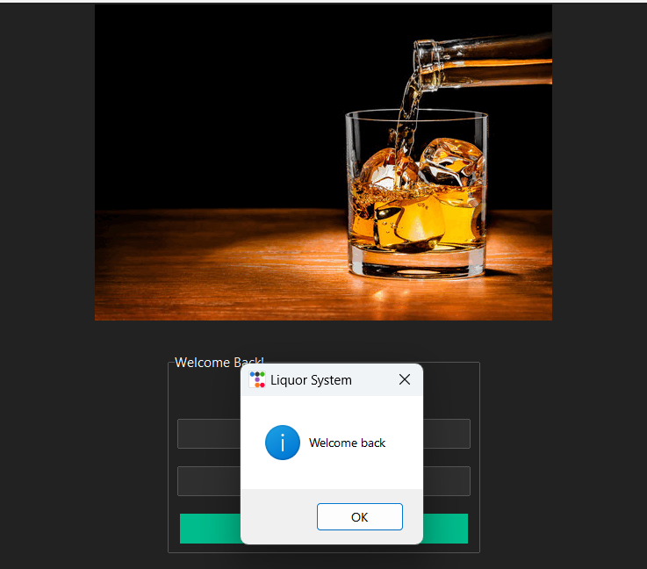

**Sales Module**

**Search Items**

1. From the main menu, click the **Sales** button.
2. Enter the **Item ID** in the search bar.
3. The system retrieves the item details, including name, size, quantity, and price.

**Add to Cart and Checkout**

1. Specify the quantity of the item you want to purchase.
2. Click **Add to Cart** to include the item in the transaction.
3. Once all items are added to the cart, click **Checkout.**
4. A popup window will display the **Total Sale Amount** and **Tax Amount.**

**Items Module**

**Add Item**

1. From the main menu, click the **Items** button.
2. Select **Add Item** from the options.
3. Enter the following details:
   * **Item ID**
   * **Product Name**
   * **Size**
   * **Quantity**
   * **Price**
4. Click **Save** to add the item to the inventory.A screenshot of a computer

   Description automatically generated

**Modify Item**

1. From the Items menu, click **Modify Item**.
2. Search for the item using its **Item ID** or name.
3. Update the necessary details.
4. Click **Save** to apply the changes.

**Delete Item**

1. From the Items menu, click **Delete Item**.
2. Search for the item you wish to remove.
3. Click **Delete** and confirm the action.

**Manage Users Module**

**Add User**

1. From the main menu click **Manage Users.**
2. Select **Add User** from the options.
3. Enter the following details:

* **User ID**
* **Username**
* **Password**
* **Permissions** (Choose form Admin, Sales, or Inventory using the dropdown menu.)

1. Click **Save** to create new user.

**Delete User**

1. From the Manage Users menu, click **Delete User.**
2. Search for the user to be removed.
3. Click **Delete** and confirm the action

**Exit Application**

1. To close the application, click the Exit button on the main menu.
2. All changes and transactions are saved automatically before the application closes.

**Details**

1. **Inventory Management**
   1. **Requirement:** The system must provide an efficient way to track stock levels and manage product details such as name, size, price, and quantity.
   2. **Implementation**: The Items module addresses this requirement by allowing users to add, modify, and delete inventory items. Each item is identified using a unique ID or barcode, ensuring precise tracking. The database automatically updates stock levels after each sale and logs modifications for accuracy. Backup creation during every update safeguards against data loss. This implementation ensures real-time inventory tracking and supports manual and automated workflows.
2. **Sales Tracking**
   1. **Requirement:** The system should allow users to process sales, calculate totals with taxes, and record each transaction for future reference.
   2. **Implementation:** The Sales module fulfills this by integrating with the database to handle transactions. Users can search for items, specify quantities, and add them to the cart. Upon checkout, the system calculates the total sale, including applicable taxes, and records the transaction in the database. This ensures traceability and seamless inventory updates, keeping stock levels accurate and providing detailed records for reporting and analysis.
3. **User Management**
   1. **Requirement:** Implement role-based access control to restrict sensitive operations and ensure only authorized personnel can make critical changes to the system.
   2. **Implementation:** The Manage Users module supports creating and managing user accounts with assigned roles. Roles such as Admin, Sales, and Inventory define user permissions, limiting access to specific functionalities. For instance, Sales personnel can only process transactions, while Admin users can add or remove other users. Password encryption and activity logging enhance system security, ensuring accountability and restricted access to sensitive operations.
4. **Security**
   1. **Requirement:** Protect sensitive data, prevent unauthorized access, and maintain system integrity.
   2. **Implementation:** Security measures include encrypted password storage and role-based access controls. The system restricts actions based on user permissions, ensuring only authorized users can access or modify critical data. Logs are maintained for all activities, allowing administrators to monitor and audit user actions. If an employee leaves, their account can be quickly deactivated to prevent misuse.
5. **Reporting**
   1. **Requirement:** Generate logs and summaries of inventory and sales to help store owners analyze business performance.
   2. **Implementation:** Reporting is automated through transaction logging in the database. Every sale, inventory update, or user action generates an entry in the system's logs. These records can be queried to create sales summaries, inventory status reports, and user activity audits. This feature allows business owners to track performance metrics, identify trends, and make informed decisions based on accurate data.

**Summary**

The Liquor Sales Inventory System is an innovative application tailored for liquor stores to manage sales, inventory, and user roles efficiently. This document outlines the steps for installation, navigation, and feature usage, along with the system's alignment with its initial requirements. Designed with user-friendliness, security, and operational efficiency in mind, the system ensures accurate and reliable performance. By adhering to this guide, users can optimize their store operations and achieve greater productivity with minimal effort.